RECREATIONAL ESTABLISHMENT LICENSE APPLICATION

Form Completion and Accessibility
- Starting on the next page, please complete all fields unless otherwise noted.
- Electronic completion is appreciated when possible.
- Need this content in an accessible format? Please contact eoh@fpm.wisc.edu for assistance.

PLAN REVIEW & APPLICATION PROCESS
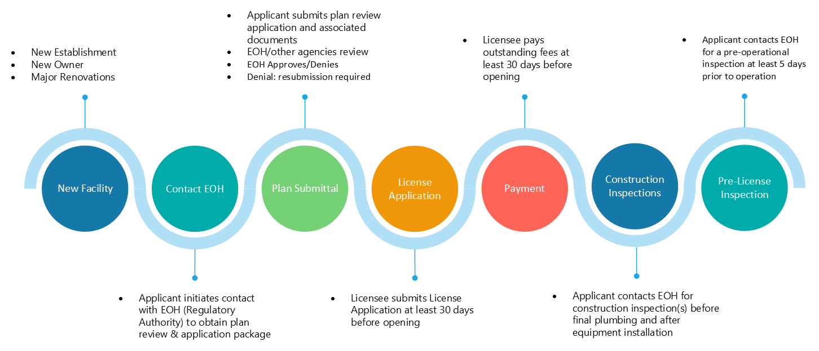

APPLICANT INFORMATION
Applicant’s Name:
Title (owner, manager, architect, etc.):
Email:
Phone:
Projected Date for Opening:

LICENSEE INFORMATION
Name of Owner(s):
Email Address:
Name of Licensee (LLC, Sole Proprietor, etc.):
Mailing Address
City/State/Zip:
Phone:

BILLING INFORMATION
- In most cases, annual license and pre-license inspection fees are determined by a risk rating assessment. Please refer to the relevant administrative code or contact EOH@FPM.wisc.edu for more details on how risk ratings are calculated. Visit ehs.wisc.edu for fee structure; email eoh@wisc.edu for cost projections and/or questions.
- EOH typically bills for services 30–60 days prior to a facility’s projected opening date.
- Help us support you efficiently; please share any billing timelines before submitting. Reimbursement is not guaranteed; therefore, early communication is strongly encouraged to avoid disruptions.
Name of Financial Contact (person in business office/accounting):
Financial Contact Email Address:
Mailing Address
City/State/Zip:
Financial Contact Phone:

Workday Funding, UW-Madison Only*
WD Cost Center Description
Ex: UWMSN | FPM | Environmental, Health, and Safety (EHS) | Environmental and Occupational Health
WD COST CENTER  (CC + 6 Digits) | WD FUND  (FD + 4 Digits) | WD FUNCTION  (FN + 4 Digits) | WD DRIVER WORKTAG  (PG/GR/GF/PJ + 9 Digits)

ESTABLISHMENT INFORMATION
Reason for application: | ☐ New ☐ Remodel ☐ Change of Operator
Name of Establishment:
Address (+Sublocations-if applicable):
Phone:
Hours of Operation: | Mon: | Tues: | Wed: | Thurs:
Hours of Operation: | Fri: | Sat: | Sun:
Select Category (fill out applicable section below): | ☐ Public Pools or Water Attraction  ☐ Hotel/Motel  ☐ Tourist Rooming House  ☐ Recreational and Educational Camps

PUBLIC POOLS & WATER ATTRACTIONS
The pool type is a Whirlpool or Therapy pool? |  | ☐ Yes ☐ No
Choose the applicable recirculation system: | ☐ Designated to a single pool basin  ☐ Shared with another pool basin
The basin is greater than 1999 square feet in area? |  | ☐ Yes ☐ No
The pool has one or more features? |  | ☐ Yes ☐ No
The pool is defined as a water attraction? |  | ☐ Yes ☐ No

RECREATIONAL AND EDUCATIONAL CAMPS
Provides on−premises or off−premises waterfront activities including: swimming, kayaking, boating, sailing, canoeing, or inflatables to campers. This does not include vendor provided waterfront activities. |  | ☐ Yes ☐ No
Offers camper firearm activity on−premises |  | ☐ Yes ☐ No
Offers archery, ax, hatchet, knife throwing to campers on−premises. |  | ☐ Yes ☐ No
Offers high element challenge course to campers on−premises. |  | ☐ Yes ☐ No
Offers low element challenge course to campers on−premises. |  | ☐ Yes ☐ No
Offers horseback riding to campers on−premises. |  | ☐ Yes ☐ No
Offers motorized vehicle activity for campers on−premises including go−kart, all−terrain vehicle, or utility−terrain vehicle. |  | ☐ Yes ☐ No
Serves rental group(s) including a school, church group, or scout troop. |  | ☐ Yes ☐ No
Camp premises includes structures that are utilized for lodging, dining, health services, waterfront activities, water supply systems, or challenge courses that require inspection travel beyond a half mile from the main centralized camper drop off or welcome location (basic services that are spread out, or distant service areas). |  | ☐ Yes ☐ No
Utilizes more than 3 private wells to supply camp drinking water. |  | ☐ Yes ☐ No
Utilizes more than one kitchen or physical building with kitchen preparation space to serve meals to campers. |  | ☐ Yes ☐ No
Camp sleeping structures; choose one of the following: | ☐ 1-10 stand−alone sleeping structures including a cabin, yurt, covered wagon, Adirondack shelter, or platform tent.  ☐ 11−20 stand−alone sleeping structures.  ☐ 21 or more stand−alone sleeping structures.
Hospitality add-on: Does the licensed recreational and educational camp also offer additional activity such as a retail food establishment, campground, hotel, motel, bed and breakfast, or a tourist rooming house within the confines of the recreational and education camp, utilizing the same camp structures to serve other adult guests and their families? |  | ☐ Yes ☐No

HOTELS, MOTELS, AND TOURIST ROOMING HOUSES
Choose the applicable license category & number of individually keyed units:
☐ Hotel/Motel  ☐ 5 to 30  ☐ 31 to 99  ☐ 100 to 249  ☐ 250 to 499  ☐ 500 to 749  ☐ 750 to 1000  ☐ 1000+ | ☐ Tourist Rooming House  ☐ 1  ☐ 2 to 4  ☐ 5 to 9  ☐ 10 to 19  ☐ 20 to 39  ☐ 40 to 99  ☐ 100 to 299  ☐ 300 to 599  ☐ 600+ | ☐ Specialty Loding  ☐ 1  ☐ 2 to 4  ☐ 5 to 9  ☐ 10 to 19  ☐ 20 to 39  ☐ 40 to 99

STATEMENT: I hereby certify that the above information is correct, and I fully understand that any deviation from the above without prior permission from UW-Madison Environment, Health & Safety may nullify final approval.

Signature(s) ___________________________________________ Date___________
Owner(s) or Responsible Representative(s)

ENVIRONMENT, HEALTH & SAFETY REVIEW
Approval of this application by UW-Madison Environment, Health & Safety does not indicate compliance with any other code, law or regulation that may be required (federal, state, or local). It further does not constitute endorsement or acceptance of the completed establishment (structure or equipment). A pre-opening inspection of the establishment where all equipment is in place and operational will be necessary to determine if compliance with the local and state laws governing food service establishments is met.

Authorized Employee |  | Application Approval Date
License Category Determination |  | License Expiration Date
Pre-license Inspection Cost |  | Annual License Cost
Bill on Date |  | Total to be Billed

