RETAIL FOOD ESTABLISHMENT LICENSE APPLICATION

Form Completion and Accessibility
- Starting on the next page, please complete all fields unless otherwise noted.
- Electronic completion is appreciated when possible.
- Need this content in an accessible format? Please contact eoh@fpm.wisc.edu for assistance.

PLAN REVIEW & APPLICATION PROCESS
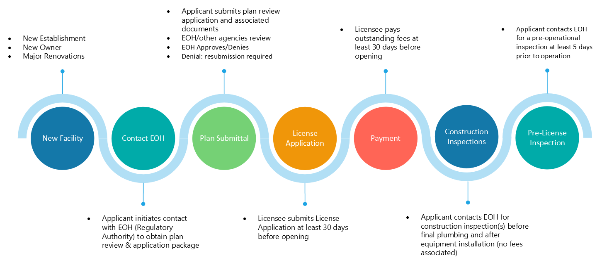

APPLICANT INFORMATION
Applicant’s Name:
Title (owner, manager, architect, etc.):
Email:
Phone:
Projected Date for Opening:

LICENSEE INFORMATION
Name of Owner(s):
Email Address:
Name of Licensee (LLC, Sole Proprietor, etc.):
Mailing Address
City/State/Zip:
Phone:

BILLING INFORMATION
- In most cases, annual license and pre-license inspection fees are determined by a risk rating assessment. Please refer to the relevant administrative code or contact EOH@FPM.wisc.edu for more details on how risk ratings are calculated. Visit ehs.wisc.edu for fee structure; email eoh@wisc.edu for cost projections and/or questions.
- EOH typically bills for services 30–60 days prior to a facility’s projected opening date.
- Help us support you efficiently; please share any billing timelines before submitting. Reimbursement is not guaranteed; therefore, early communication is strongly encouraged to avoid disruptions.
Name of Financial Contact (person in business office/accounting):
Financial Contact Email Address:
Mailing Address
City/State/Zip:
Financial Contact Phone:

Workday Funding, UW-Madison Only
WD Cost Center Description
Ex: UWMSN | FPM | Environmental, Health, and Safety (EHS) | Environmental and Occupational Health
WD COST CENTER  (CC + 6 Digits) | WD FUND  (FD + 4 Digits) | WD FUNCTION  (FN + 4 Digits) | WD DRIVER WORKTAG  (PG/GR/GF/PJ + 9 Digits)
ESTABLISHMENT INFORMATION
Reason for application: |  | ☐ New ☐ Remodel ☐ Change of Operator
Name of Establishment:
Address (+Sublocations or Mobile Base Locations-if applicable):
Phone:
Certified Food Protection (CPFM) Manager Name: |  |  |  | CPFM Expiration Date:
Hours of Operation: |  | Mon: | Tues: | Wed: | Thurs:
 |  | Fri: | Sat: | Sun:
Category: |  | ☐ Serving mostly meals  ☐ Serving mostly retail (non-meal items)
Estimated annual gross food sale receipts: |  | ☐ <$25,000  ☐ $25,000 - $1,000,000  ☐ >$1,000,000 - <$5,000,000  ☐ >$5,000,000
Food Establishment:
Only sells pre-packaged food or meal items, regardless of if the food items are time/temperature controlled for safety food. |  |  |  |  | ☐ Yes ☐ No
Is a “mobile food establishment” as defined in ATCP 75 Appendix. |  |  |  |  | ☐ Yes ☐ No
Contains a self-service salad or food bar. |  |  |  |  | ☐ Yes ☐ No
Handles raw poultry, meat, eggs, or seafood. |  |  |  |  | ☐ Yes ☐ No
Has a bare hand contact plan or time as a public health control plan. |  |  |  |  | ☐ Yes ☐ No
Has a catering operation or processes, packages, or holds customer preordered meals or food items. |  |  |  |  | ☐ Yes ☐ No
Does cold holding, hot holding, or reheating of  time/temperature control for safety (TCS) foods. |  |  |  |  | ☐ Yes ☐ No
Does cooling of cooked or reheated time/temperature control for safety foods. |  |  |  |  | ☐ Yes ☐ No
Prepares TCS (time/temp controlled for safety) food at its location and transports it to be sold, under the wholesale exemption, to other food establishments. |  |  |  |  | ☐ Yes ☐ No
Serves or sells food that requires food processing activities including chopping, dicing, mixing, slicing, blanching, boiling, cooking, packaging, and assembly in order for that product to be served or sold. |  |  |  |  | ☐ Yes ☐ No
Has additional area(s) where food preparation activities occur (additional kitchens, serveries, plating areas). |  |  |  |  | ☐ Yes ☐ No
Specifically prepares or serves food to a population identified as highly susceptible, such as a nursing home or day care. |  |  |  |  | ☐ Yes ☐ No
Has a customer seating capacity greater than 75, or  operates a motor vehicle drive-thru window for food purchase and service. |  |  |  |  | ☐ Yes ☐ No
Will you be doing any of the following? Check all that apply. | ☐ Smoking food for preservation  ☐ Curing food  ☐ Using food additives or adding components such as vinegar to render food non-PHF  ☐ ROP (vacuum sealing), cook-chill, sous vide  ☐ Operating molluscan shellfish tank  ☐ Custom processing  ☐ Sprouting seeds or beans  ☐ Slaughter or evisceration of fish

************
STATEMENT: I hereby certify that the above information is correct, and I fully understand that any deviation from the above without prior permission from UW-Madison Environment, Health & Safety may nullify final approval.

Signature(s) ___________________________________________ Date___________
Owner(s) or Responsible Representative(s)

ENVIRONMENT, HEALTH & SAFETY REVIEW
Approval of this application by UW-Madison Environment, Health & Safety does not indicate compliance with any other code, law or regulation that may be required (federal, state, or local). It further does not constitute endorsement or acceptance of the completed establishment (structure or equipment). A pre-opening inspection of the establishment where all equipment is in place and operational will be necessary to determine if compliance with the local and state laws governing food service establishments is met.

Authorized Employee |  | Application Approval Date
License Category Determination |  | License Expiration Date
Pre-license Inspection Cost |  | Annual License Cost
Bill on Date |  | Total to be Billed

