TRANSIENT RETAIL FOOD ESTABLISHMENT LICENSE APPLICATION

Form Completion and Accessibility
- Starting on the next page, please complete all fields unless otherwise noted.
- Electronic completion is appreciated when possible.
- Need this content in an accessible format? Please contact eoh@fpm.wisc.edu for assistance.

APPLICATION PROCESS
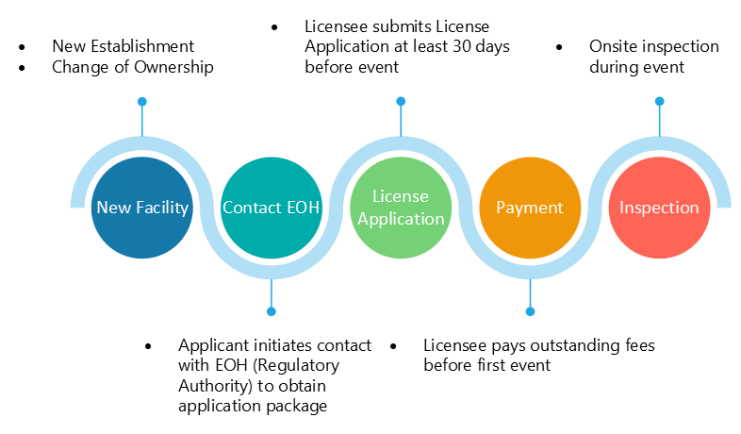

APPLICANT INFORMATION
Applicant’s Name:
Title (owner, manager, architect, etc.):
Email:
Phone:
Projected Date for Opening/First Event Date:

LICENSEE INFORMATION
Name of Owner(s):
Email Address:
Name of Licensee (LLC, Sole Proprietor, etc.):
Mailing Address
City/State/Zip:
Phone:

BILLING INFORMATION
- In most cases, annual license fees are determined by a risk rating assessment. Please refer to the relevant administrative code or contact EOH@FPM.wisc.edu for more details on how risk ratings are calculated. Visit ehs.wisc.edu for fee structure; email eoh@wisc.edu for cost projections and/or questions.
- EOH typically bills for services 30–60 days prior to a facility’s projected opening date/first event date.
- Help us support you efficiently; please share any billing timelines before submitting. Reimbursement is not guaranteed; therefore, early communication is strongly encouraged to avoid disruptions.
Name of Financial Contact (person in business office/accounting):
Financial Contact Email Address:
Mailing Address
City/State/Zip:
Financial Contact Phone:

Workday Funding, UW-Madison Only*
WD Cost Center Description
Ex: UWMSN | FPM | Environmental, Health, and Safety (EHS) | Environmental and Occupational Health
WD COST CENTER  (CC + 6 Digits) | WD FUND  (FD + 4 Digits) | WD FUNCTION  (FN + 4 Digits) | WD DRIVER WORKTAG  (PG/GR/GF/PJ + 9 Digits)
ESTABLISHMENT INFORMATION
Reason for application: | ☐ New ☐ Change of Operator
Name of Establishment:
Event Location(s)
(+Sublocations-if applicable):
Event Date(s):
Menu:
Category: | ☐ Serving mostly meals ☐ Serving mostly retail (non-meal items)
Food establishment only sells pre-packaged food or meal items. |  | ☐ Yes ☐ No
Final products are considered time/temperature controlled for safety food. |  | ☐ Yes ☐ No
Food establishment handles raw poultry, meat, eggs, or seafood. |  | ☐ Yes ☐ No
Food establishment has a time as a public health control plan. |  | ☐ Yes ☐ No
Food establishment does cold holding, hot holding, or reheating of  time/temperature control for safety (TCS) foods. |  | ☐ Yes ☐ No

************
STATEMENT: I hereby certify that the above information is correct, and I fully understand that any deviation from the above without prior permission from UW-Madison Environment, Health & Safety may nullify final approval.

Signature(s) ___________________________________________ Date___________
Owner(s) or Responsible Representative(s)

ENVIRONMENT, HEALTH & SAFETY REVIEW
Approval of this application by UW-Madison Environment, Health & Safety does not indicate compliance with any other code, law or regulation that may be required (federal, state, or local). It further does not constitute endorsement or acceptance of the completed establishment (structure or equipment). A pre-opening inspection of the establishment where all equipment is in place and operational will be necessary to determine if compliance with the local and state laws governing food service establishments is met.

Authorized Employee |  | Application Approval Date
License Category Determination |  | License Expiration Date
Pre-license Inspection Cost |  | Annual License Cost
Bill on Date |  | Total to be Billed

